Design Documentation

This programming assignment combines Graham’s scan and divide-and-conquer two algorithms to solve the problem of finding a convex hull among certain numbers of points.
Suppose we have a certain number of points set Q. Divide-and-conquer method recursively divides Q into two subsets until each becomes small enough to have at least two or more points and thus to create a triangle or a line segment quickly as a convex hull.

- parallelization strategies
Parallelization is a type of computation in which many calculations or the execution of processes are carried out simultaneously. Large problems, in this case convex hull which is a computational task, can be divided into smaller ones, which can then be solved at the same time. The results are combined afterwards, upon completion. Therefore, we can maximum the utilization of CPU cores to improve the performance.
Divide-and-conquer method will parallelize multiple processes to improve performance. In the process of divide-and-conquer, assume that we want to parallelize N processes. Then, each process will take around Q/N of subset of the original set. These processes work on their own sub-space in parallel simultaneously.
When user input N number of process. This parallel program will create N-1 child processes and involve all N processes in parallel computation. For instance, when four processes parallelize, the computer with 4 processors will take these four processes and do the calculation at the same time. Therefore, the performance improves remarkably.

2. more details of Divide-and-conquer method
- Process of divide
To be more specific, Figure 1 illustrates how the task is divided. In Divide-and-conquer method, when I recursively divide Q into two smaller subsets, I fork() a child process and let it work on the right subset, whereas have the original parent take care of the left subset. All point data including global and local variables are automatically copied to the new children process. Check the processNum(the number of desire process) pass from parameter. If it is still bigger than one, create a new child respectively, and let the child take care of half of its set.
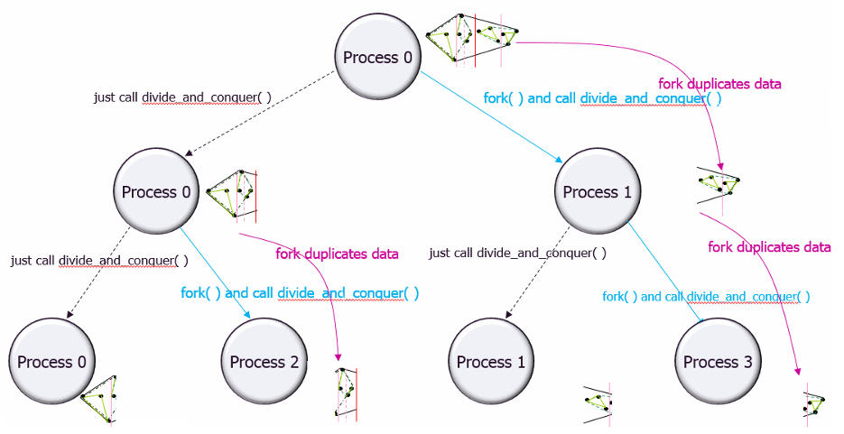 (Figure 1)
Note that the program only accepts even number process. If the user inputs any odd number, the program will only create even number of process which is equal to input-1.

- Process of merge and send back message
After Graham scan, child process need to send the sub convex hull back to its parent process through a pipe. Therefore, every time before a parent forks a new child, I create a pipe in advance. The child process closes its pipe’s read side and call set() method to write the data to pipe. The parent process closes its pipe’s write side and call recv() method to read the data from pipe. Figure 2 illustrates all the message sending back to parent.
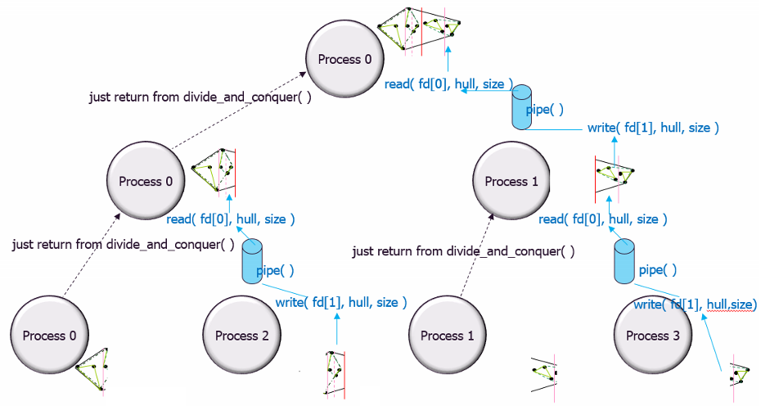 (Figure 2)

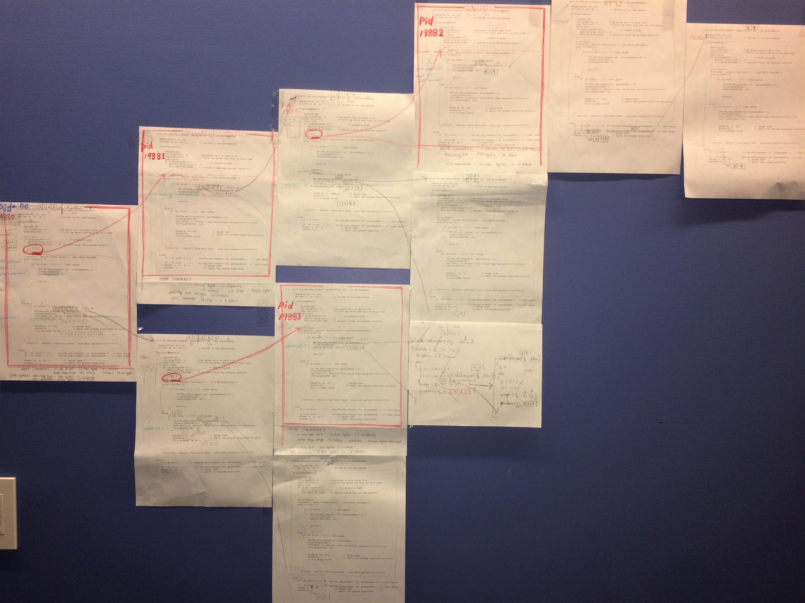

(Figure 3)

Figure 3 is a picture that how I simulates the parallelization process on hard copy. The pages with a red rectangle stand for different new processes.
Other pages stand for recursive calls. I use 10 points and 4 process to try to simulate how parent process creates its child and divides the task.

Discuss Results

- Analysis of the effectiveness of your parallelization.
Parallelization was done only in divide-and-conquer method. This method recursively divide task into two smaller subtask, I fork() a child process and let it work on the right subset, whereas have the original parent take care of the left subset. Each process can be processed independently. The performance improvement is remarkably.

- Performance improvemnet
The performance improvement with 2 processes applied to 20,000 points is 121819/66667 about 1.8 times
The performance improvement with 4 processes applied to 20,000 points is 121819/40524 about 3.0 times
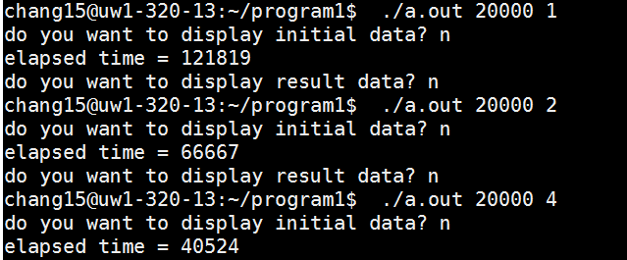

- Too small task or IO task
Parallelization is more efficient only if we deal with big problem. Especially the big computational task. In the example I give below, I applied 1 point and 10 points to the task. The time using obviously increases with more processes. This is because that the CPU running time is not only counted by calculation time but also context switching (overhead) time. In the case of not enough computational task to divide, the CPU spend more time on overhead. Other than that, if the process contain more IO task but not computation task, the performance also will not be remarkable different, because IO can be hundred time slower than computation. Divide IO task will not help with the performance.
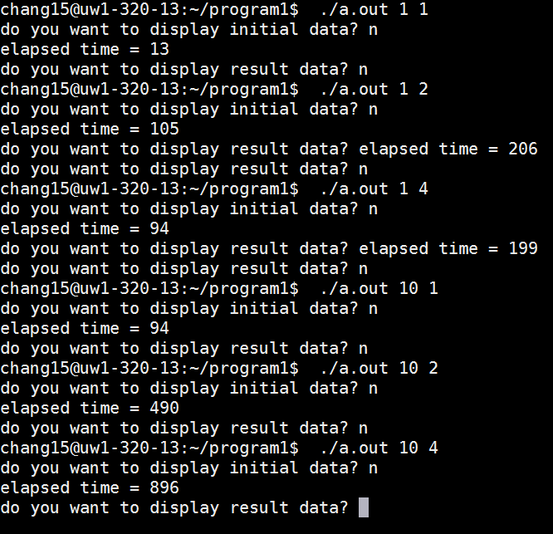

- Too many process
The example below shows that parallelizing too many process also will not help with the process. This is mainly because that when we run a too many process on the machine without that amount of processors or cores, the processes are not running parallelized. Since the processors or cores are not enough for so many processes to use, processors have to switch between those processes and let them share the CPU resource. In that case, it becomes a concurrency programming, and overhead takes a lot of time. The performance might be decline by the number of processes increasing.
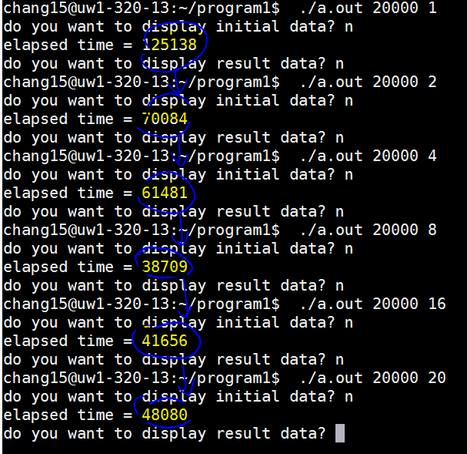

- Oscillations performance
However, there are oscillations with the performance. I suppose this might cause by multi factors. One mainly reason might be that there are numbers of users a using the same Linux machine, when multi process are running on the same machine, the result can be affected.
There is an interesting pattern. I found that when running from more processors to less processor order, the performance is always better than from less to more. I haven’t figure out what cause this result. I am not sure if this is related with the memory use (since there are still some memory leak haven’t been deallocated from stack). I will keep study this problem in my future study.
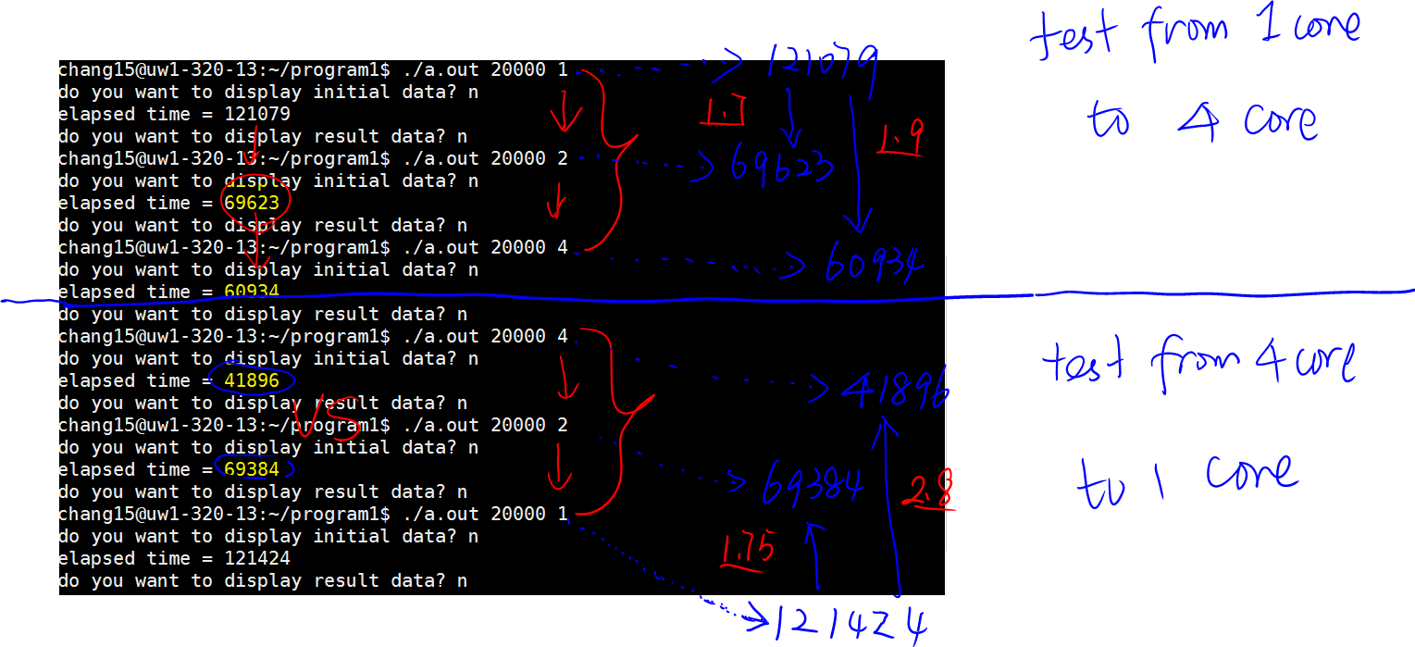

Possible performance improvement of your program.
- Wait() system call
Instead of using wait(NULL), I use wait_pid( pid, NULL, 0). Wait(NULL) will clear data for any terminate child process. In case of waiting the wrong child and clearing wrong data, I use wait_pid( pid, NULL, 0) to wait the child process specified by pid.

- Fix the memory leak
The memory leak problem that I will give more details in next session might bring problems which affect performance. Thus, it’s always good to fix all the memory leak.

- Improve the Graham algorithm
Though the complexity of the Graham algorithm (nlogn) is very good, the overall running time will improve as well if we can improve that,.

- Thread
Instead of creating more processes, a better solution can be creating thread. Thread is lighter process. CPU can deal with thread more efficiently.

- Run on a multi-processor machine
Since this is a typical computational task problem, a machine with more processors or cores will allow more processes to run parallel in order to increase performance.

Limitations of your program
- Memory leak
This program has obvious memory leak, since it doesn’t delete all the points which is dynamic allocated. Each point allocates 24 byte of memory space. Therefore, when try to apply 20000 points with 4 process, the memory leak will be 24*20000*4 = 1290000 byte which is 1.29Mbyte. With this memory on heap, it will affect the program performance in some way.

- The time measurement might not shows the accurate running time
Since the CPU scheduling is rather complex, it’s very likely that there are some other process (especially higher priority process or thread) are running with this process simultaneously. In that case, there is always an oscillation in the performance obtained on parallelization.

